Unit-2
Concept of AWT (Abstract Window Toolkit):
Java AWT is an API that contains large number of classes and methods to create and manage graphical user interface ( GUI ) applications. The AWT was designed to provide a common set of tools for GUI design that could work on a variety of platforms. The tools provided by the AWT are implemented using each platform's native GUI toolkit, hence preserving the look and feel of each platform. This is an advantage of using AWT. But the disadvantage of such an approach is that GUI designed on one platform may look different when displayed on another platform that means AWT component are platform dependent.
AWT is the foundation upon which Swing is made i.e Swing is a improved GUI API that extends the AWT. But now a days AWT is merely used because most GUI Java programs are implemented using Swing because of its rich implementation of GUI controls and light-weighted nature.
The following image represents the hierarchy for Java AWT.
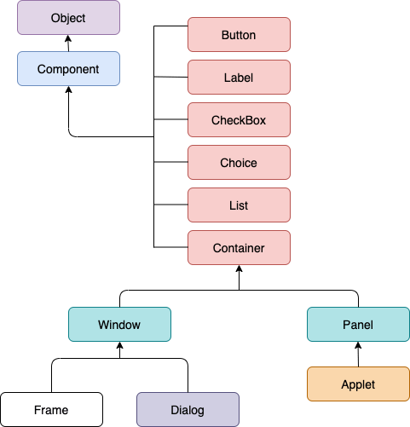
Component Class
The component class stands at the top of the AWT hierarchy, is an abstract class that contains all the properties of the component visible on the screen.
It is the base class of all the GUI elements that are visible in user screen.
Like button, labels, checkbox and combobox are visible.
Object class is super class of component class
It handle layout display, manages events, set (size, position, visibility)

Container
The container is a component that contains other components like button, textfield, label, etc. However, it is a subclass of the Component class.
Panel
can be defined as a container that can be used to hold other components. However, it doesn't contain the title bar, menu bar, or border.
Window
A window can be defined as a container that doesn't contain any border or menu bar. It creates a top-level view. However, we must have a frame, dialog, or another window for creating a window.
Frame
The frame is a subclass of Window. It can be defined as a container with components like button, textfield, label, etc. In other words, AWT applications are mostly created using frame container.
Creating a Frame
There are two ways to create a Frame. They are,
- By Instantiating Frame class
- By extending Frame class
Creating Frame Window by Instantiating Frame class
import java.awt.*;
public class App {
App()
{
Frame fm=new Frame(“Title”); //Creating a frame
Label lb = new Label("welcome to java graphics"); //Creating a label
fm.add(lb); //adding label to the frame
fm.setSize(300, 300); //setting frame size.
fm.setVisible(true); //set frame visibilty true
}
public static void main(String[] args)
{
new App();
}
}

Output:
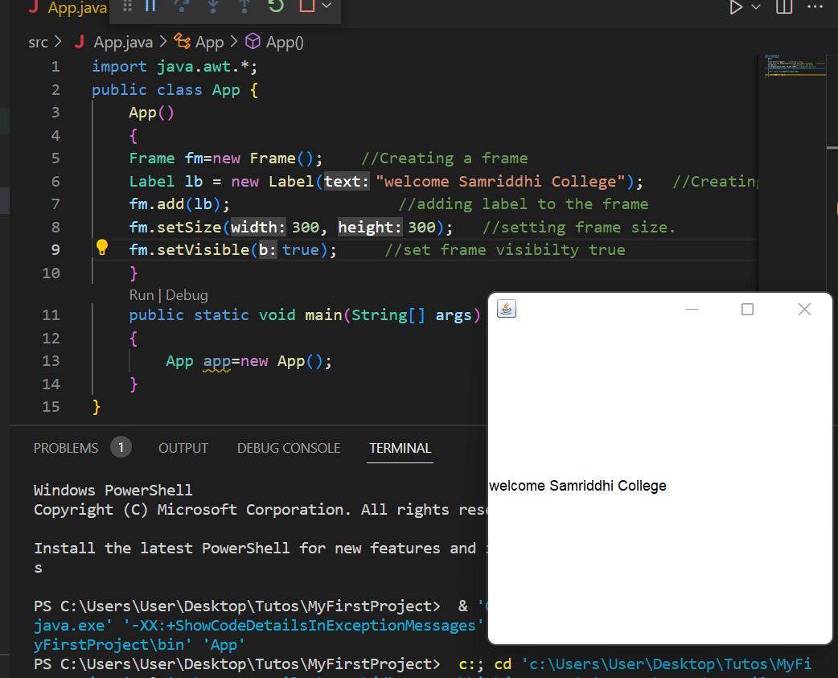

Creating Frame window by extending Frame class
Code: import java.awt.*;
public class App extends Frame{
App()
{
Button btn=new Button("Hello World");
add(btn); //adding a new Button.
setSize(400, 500); //setting size.
setTitle("StudyTonight"); //setting title.
setLayout(new FlowLayout()); //set default layout for frame.
setVisible(true); //set frame visibilty true.
}
public static void main(String[] args)
{
App app=new App();
}
}

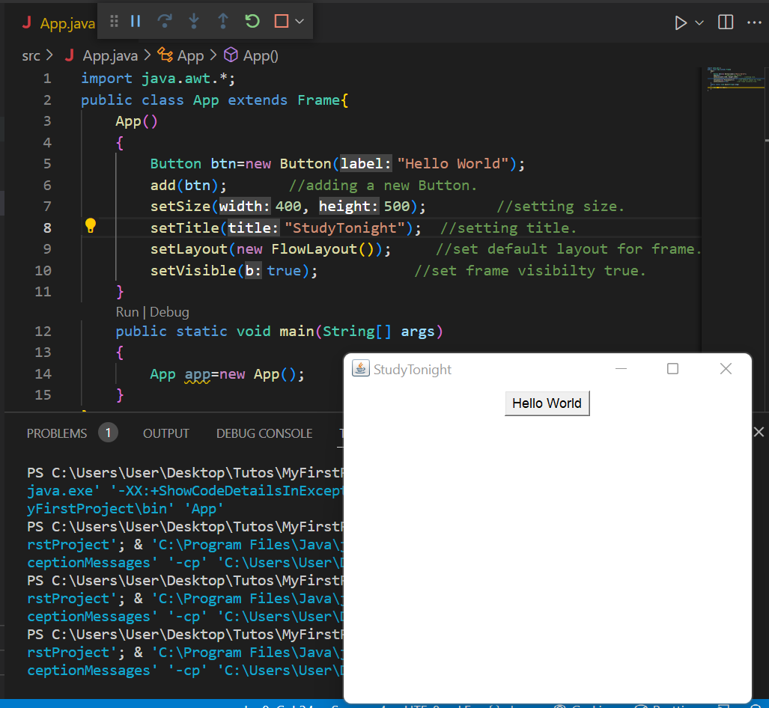

Java AWT Vs Swing
AWT | Swing
AWT stands for “Abstract Windows Toolkit”. | Swing is derived from Java Foundation Classes (JFC)
AWT components are heavyweight as AWT directly makes subroutine calls to subroutines of the Operating System. | Swing components are written on top of AWT and as such the components are light-weight.
AWT components are part of the java.awt package. | Swing components are part of javax.swing package.
AWT is platform - dependent. | Swing components are written in Java and are platform-independent.
AWT doesn’t have its look and feel. It adapts the look and feel of the platform on which it runs. | Swing provides a different look and feel of its own.
AWT only has basic features and does not support advanced features like the table, tabbed panel, etc. | Swing provides advanced features like JTabbed panel, JTable, etc.
AWT is as good as a thin layer of classes sitting on top of the Operating system which makes it platform-dependent. | Swing is larger and also contains rich functionality.
AWT makes us write a lot of things. | Swing has most of the features built-in.

Java Applet
Applet is a special type of program that is embedded in the webpage to generate the dynamic content. It runs inside the browser and works at client side.
Advantage of Applet
There are many advantages of applet. They are as follows:
- It works at client side so less response time.
- Secured
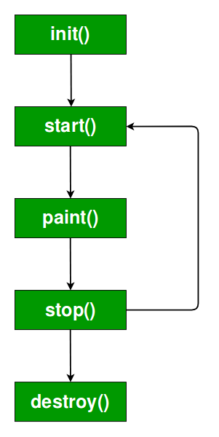
- It can be executed by browsers running under many platforms, including Linux, Windows, Mac Os etc.

Lifecycle of Java Applet
- Applet is initialized.
- Applet is started.
- Applet is painted.
- Applet is stopped.
- Applet is destroyed.

How to run an Applet?
There are two ways to run an applet
- By html file.
- By appletViewer tool (for testing purpose).

Swing:
Java Swing is a part of Java Foundation Classes (JFC) that is used to create window-based applications. It is built on the top of AWT (Abstract Windowing Toolkit) API and entirely written in java.
Unlike AWT, Java Swing provides platform-independent and lightweight components.
The javax.swing package provides classes for java swing API such as JButton, JTextField, JTextArea, JRadioButton, JCheckbox, JMenu, JColorChooser etc.
What is JFC
The Java Foundation Classes (JFC) are a set of GUI components which simplify the development of desktop applications.
Hierarchy of Java Swing classes
The hierarchy of java swing API is given below.
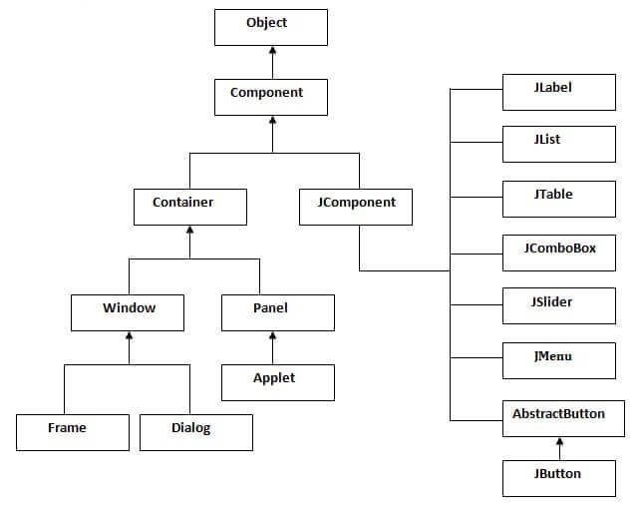
Java Swing Examples
There are two ways to create a frame:
- By creating the object of Frame class (association)
- By extending Frame class (inheritance)
We can write the code of swing inside the main(), constructor or any other method.
- By creating the object of Frame class (association)
1.By creating the object of Frame class (association)
Simple Java Swing Example
Let's see a simple swing example where we are creating one button and adding it on the JFrame object inside the main() method.
import javax.swing.*;
public class App{

public static void main(String[] args)
{
JFrame f=new JFrame();//creating instance of JFrame

JButton b=new JButton("click");//creating instance of JButton
b.setBounds(130,100,100, 40);//x axis, y axis, width, height

f.add(b);//adding button in JFrame

f.setSize(400,500);//400 width and 500 height
f.setLayout(null);//using no layout managers
f.setVisible(true);//making the frame visible
}

}

Example of Swing by Association inside constructor
We can also write all the codes of creating JFrame, JButton and method call inside the java constructor.
import javax.swing.*;
public class App{
App()
{
JFrame f=new JFrame();//creating instance of JFrame

JButton b=new JButton("click");//creating instance of JButton
b.setBounds(130,100,100, 40);//x axis, y axis, width, height

f.add(b);//adding button in JFrame

f.setSize(400,500);//400 width and 500 height
f.setLayout(null);//using no layout managers
f.setVisible(true);//making the frame visible
}

public static void main(String[] args)
{
App app=new App();
}

}

2.Simple example of Swing by inheritance
We can also inherit the JFrame class, so there is no need to create the instance of JFrame class explicitly.
import javax.swing.*;
public class App extends JFrame{
JFrame f;
App()
{
JButton b=new JButton("click");//create button
b.setBounds(130,100,100, 40);

add(b);//adding button on frame
setSize(400,500);
setLayout(null);
setVisible(true);
}

public static void main(String[] args)
{
App app=new App();
}

}

Layout Management:
The LayoutManagers are used to arrange components in a particular manner. The Java LayoutManagers facilitates us to control the positioning and size of the components in GUI forms. LayoutManager is an interface that is implemented by all the classes of layout managers. There are the following classes that represent the layout managers:
The Abstract Windowing Toolkit (AWT) has the following five layout managers:
- java.awt.BorderLayout
- java.awt.FlowLayout
- java.awt.GridLayout
- java.awt.CardLayout
- java.awt.GridBagLayout
Some of these are used in the swing:
- javax.swing.BoxLayout
- javax.swing.ScrollPanelLayout
- javax.swing.GroupLayout
- javax.swing.SpringLayout
No Layout:
import javax.swing.*;
public class App extends JFrame{
JFrame f;
App()
{
JButton b=new JButton("click");//create button
b.setBounds(130,100,100, 40);

add(b);//adding button on frame
setSize(400,500);
setLayout(null);
setVisible(true);
}
public static void main(String[] args)
{
App app=new App();
}

}

Flow Layout:
The Java FlowLayout class is used to arrange the components in a line, one after another (in a flow). It is the default layout of the panel.
FlowLayout.LEFT | Aligns components to the left

FlowLayout.RIGHT | Aligns components to the right

FlowLayout.CENTER | Aligns components at the center (default)

FlowLayout.LEADING | Aligns components to the start of the container (depends on orientation)

FlowLayout.TRAILING | Aligns components to the end of the container (depends on orientation)

Example:
setLayout(new FlowLayout(FlowLayout.CENTER, 10, 10));
import javax.swing.*;
import java.awt.*;
public class App{
JFrame f;
App()
{
f=new JFrame();
JButton b1 = new JButton("1");
JButton b2 = new JButton("2");
JButton b3 = new JButton("3");
JButton b4 = new JButton("4");
JButton b5 = new JButton("5");
JButton b6 = new JButton("6");
JButton b7 = new JButton("7");
JButton b8 = new JButton("8");
JButton b9 = new JButton("9");
JButton b10 = new JButton("10");
f.add(b1); f.add(b2); f.add(b3); f.add(b4);
f.add(b5); f.add(b6); f.add(b7); f.add(b8);
f.add(b9); f.add(b10);
f.setLayout(new FlowLayout());
f.setSize(300, 300);
f.setVisible(true);
}
public static void main(String[] args)
{
new App();
}

}

Output:
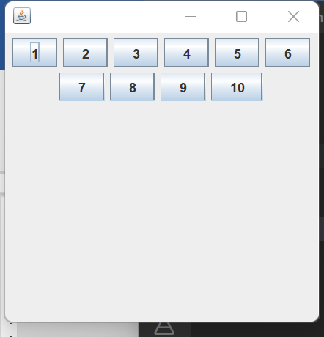

Java BorderLayout
The BorderLayout is used to arrange the components in five regions: north, south, east, west, and center. Each region (area) may contain one component only. It is the default layout of a frame or window. The BorderLayout provides five constants for each region:
- public static final int NORTH
- public static final int SOUTH
- public static final int EAST
- public static final int WEST
- public static final int CENTER
Constructors of BorderLayout class:
- BorderLayout(): creates a border layout but with no gaps between the components.
- BorderLayout(int hgap, int vgap): creates a border layout with the given horizontal and vertical gaps between the components.

Example:
import javax.swing.*;
import java.awt.*;
public class App{
JFrame f;
App()
{
f=new JFrame();
JButton b1 = new JButton("NORTH");; // the button will be labeled as NORTH
JButton b2 = new JButton("SOUTH");; // the button will be labeled as SOUTH
JButton b3 = new JButton("EAST");; // the button will be labeled as EAST
JButton b4 = new JButton("WEST");; // the button will be labeled as WEST
JButton b5 = new JButton("CENTER");;
f.add(b1, BorderLayout.NORTH); f.add(b2, BorderLayout.SOUTH);
f.add(b3, BorderLayout.EAST); f.add(b4, BorderLayout.WEST);
f.add(b5, BorderLayout.CENTER);
f.setSize(300, 300);
f.setVisible(true);
}
public static void main(String[] args)
{
App app=new App();
}

}

Output:
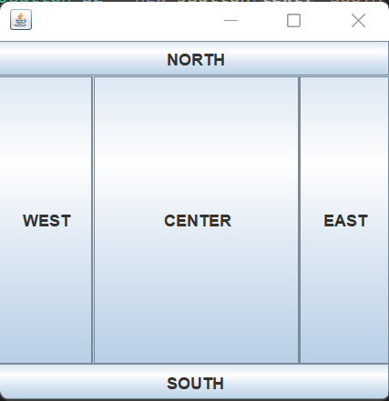

Grid Layout:
The Java GridLayout class is used to arrange the components in a rectangular grid. One component is displayed in each rectangle.
Constructors of GridLayout class
- GridLayout(): creates a grid layout with one column per component in a row.
- GridLayout(int rows, int columns): creates a grid layout with the given rows and columns but no gaps between the components.
- GridLayout(int rows, int columns, int hgap, int vgap): creates a grid layout with the given rows and columns along with given horizontal and vertical gaps.
Example:
import java.awt.GridLayout;
import javax.swing.JButton;
import javax.swing.JFrame;
public class GridLayoutExample extends JFrame{
GridLayoutExample()
{
setTitle("GridLayout Example");
setSize(300, 300);
// Set GridLayout with 3 rows and 3 columns
setLayout(new GridLayout(3, 3, 5, 5));
// Add buttons (without loop)
add(new JButton("Button 1"));
add(new JButton("Button 2"));
add(new JButton("Button 3"));

add(new JButton("Button 4"));
add(new JButton("Button 5"));
add(new JButton("Button 6"));

add(new JButton("Button 7"));
add(new JButton("Button 8"));
add(new JButton("Button 9"));

setVisible(true);
}
public static void main(String[] args) {
new GridLayoutExample();
}
}

Output:
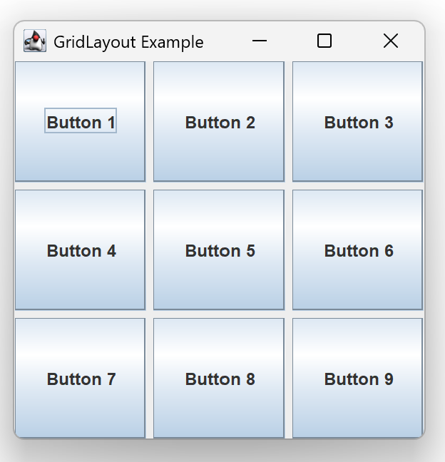

GridBagLayout:
class is used to align components vertically, horizontally or along their baseline.The components may not be of the same size. Each GridBagLayout object maintains a dynamic, rectangular grid of cells. Each component occupies one or more cells known as its display area.

Example:
import java.awt.Button;
import java.awt.GridBagConstraints;
import java.awt.GridBagLayout;
import javax.swing.*;
public class App extends JFrame{
App()
{
GridBagLayout grid = new GridBagLayout();
GridBagConstraints gbc = new GridBagConstraints();
setLayout(grid);
setTitle("GridBag Layout Example");
gbc.fill = GridBagConstraints.HORIZONTAL;
gbc.gridx = 0;
gbc.gridy = 0;
this.add(new Button("Button One"), gbc);
gbc.gridx = 1;
gbc.gridy = 0;
this.add(new Button("Button two"), gbc);
gbc.fill = GridBagConstraints.HORIZONTAL;
gbc.ipady = 20;
gbc.gridx = 0;
gbc.gridy = 1;
this.add(new Button("Button Three"), gbc);
gbc.gridx = 1;
gbc.gridy = 1;
this.add(new Button("Button Four"), gbc);
gbc.gridx = 0;
gbc.gridy = 2;
gbc.fill = GridBagConstraints.HORIZONTAL;
gbc.gridwidth = 2;
this.add(new Button("Button Five"), gbc);
setSize(300, 300);
setPreferredSize(getSize());
setVisible(true);
setDefaultCloseOperation(EXIT_ON_CLOSE);

}

public static void main(String[] args)
{
App ap=new App();
}

}

Output:
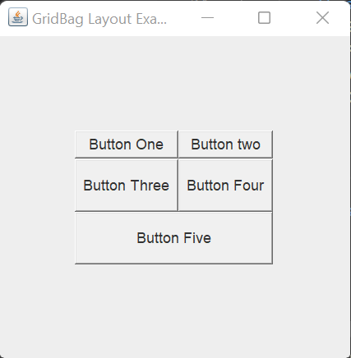

GroupLayout
GroupLayout groups its components and places them in a Container hierarchically. The grouping is done by instances of the Group class.
Example:
import java.awt.*;

import javax.swing.*;
public class App extends JFrame{

public static void main(String[] args)
{
JFrame frame = new JFrame("GroupLayoutExample");
frame.setDefaultCloseOperation(JFrame.EXIT_ON_CLOSE);
Container contentPanel = frame.getContentPane();
GroupLayout groupLayout = new GroupLayout(contentPanel);

contentPanel.setLayout(groupLayout);

JLabel clickMe = new JLabel("Click Here");
JButton button = new JButton("This Button");

groupLayout.setHorizontalGroup(
groupLayout.createSequentialGroup()
.addComponent(clickMe)
.addGap(10, 20, 100)
.addComponent(button));
groupLayout.setVerticalGroup(
groupLayout.createParallelGroup(GroupLayout.Alignment.BASELINE)
.addComponent(clickMe)
.addComponent(button));
frame.pack();
frame.setVisible(true);
}

}

Output:
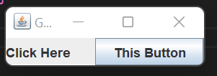

GUI Elements:
- JLabel
- JRadioButton
- ButtonGroup
- JCheckBox
- JTextField
- JTextArea
- JButton
- Border
- JComboBox
- JTabbedPane
- JPasswordField
- Look and Feel Management in Java Swing

JLabel
The object of the JLabel class may be a component for putting text in a container. It’s used to display one line of read-only text. The text is often changed by an application but a user cannot edit it directly. It inherits the JComponent class.
Syntax:
JLabel jl = new JLabel();
JLabel Constructors
- JLabel(): It is used to create a JLabel instance with no image and with an empty string for the title.
- JLabel(String s): It is used to create a JLabel instance with the specified text.
- JLabel(Icon i): It is used to create a JLabel instance with the specified image.
- JLabel(String s, Icon I, int horizontalAlignment): It is used to create a JLabel instance with the specified text, image, and horizontal alignment.
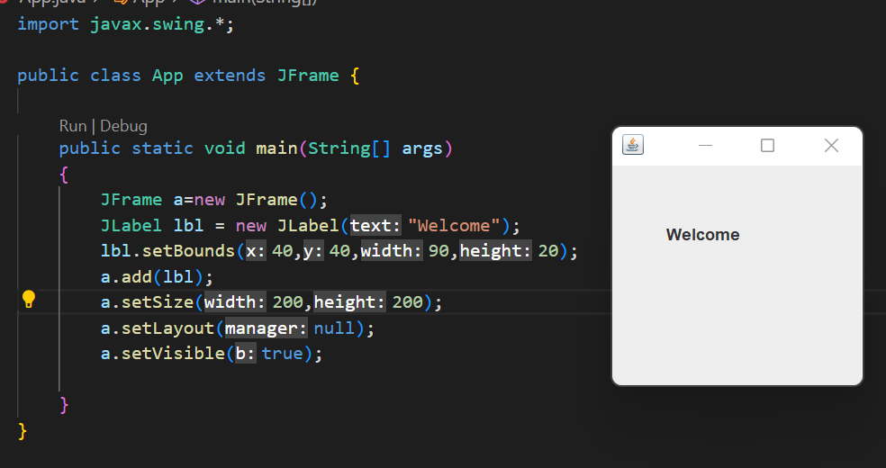
Example:

Code:
import javax.swing.*;

public class App extends JFrame {

public static void main(String[] args)
{
JFrame a=new JFrame();
JLabel lbl = new JLabel("Welcome");
lbl.setBounds(40,40,90,20);
a.add(lbl);
a.setSize(200,200);
a.setLayout(null);
a.setVisible(true);

}
}

JRadioButton
This component allows the user to select only one item from a group item. By using the JRadioButton component you can choose one option from multiple options.
Syntax: JRadioButton jrb = new JRadioButton();

JRadioButton Constructors
- JRadioButton(): It is used to create an unselected radio button with no text.
- JRadioButton(Label): It is used to create an unselected radio button with specified text.
- JRadioButton(Label, boolean): It is used to create a radio button with the specified text and selected status.

Code:
import javax.swing.*;

public class App {

public static void main(String[] args)
{
JFrame f=new JFrame();
JRadioButton r1=new JRadioButton("A) Male",true);
JRadioButton r2=new JRadioButton("B) Female");
r1.setBounds(75,50,100,30);
r2.setBounds(75,100,100,30);
ButtonGroup bg=new ButtonGroup();
bg.add(r1);
bg.add(r2);
f.add(r1);
f.add(r2);
f.setSize(300,300);
f.setLayout(null);
f.setVisible(true);

}
}

Output:
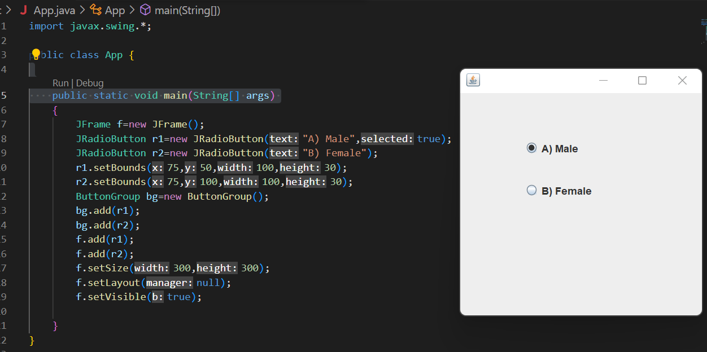
JPasswordField
The object of a JPasswordField class is a text component specialized for password entry. It allows the editing of a single line of text. It inherits JTextField class.

Constructor | Description
JPasswordField() | Constructs a new JPasswordField, with a default document, null starting text string, and 0 column width.
JPasswordField(int columns) | Constructs a new empty JPasswordField with the specified number of columns.
JPasswordField(String text) | Constructs a new JPasswordField initialized with the specified text.
JPasswordField(String text, int columns) | Construct a new JPasswordField initialized with the specified text and columns.

Code:
import javax.swing.*;

public class App {

public static void main(String[] args)
{
JFrame f=new JFrame();

JPasswordField value = new JPasswordField();
JLabel l1=new JLabel("Password:");
l1.setBounds(20,100, 80,30);
value.setBounds(100,100,100,30);
f.add(value); f.add(l1);
f.setSize(300,300);
f.setLayout(null);
f.setVisible(true);

}
}
Output:
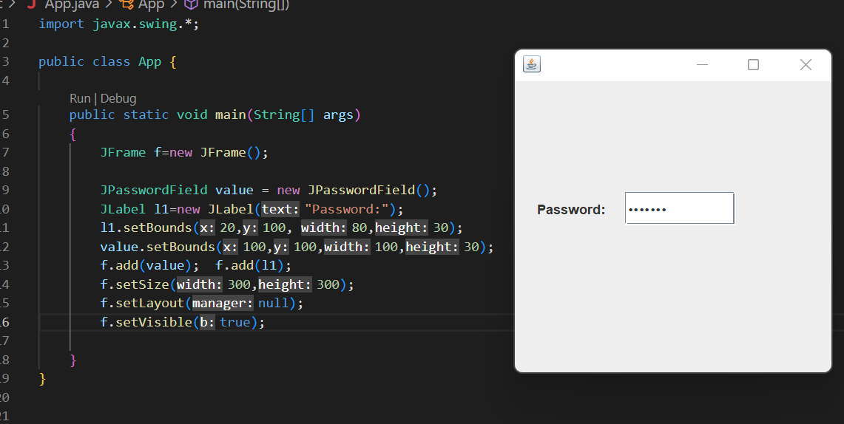
JCheckBox
The JCheckBox class is used to create a checkbox. It is used to turn an option on (true) or off (false). Clicking on a CheckBox changes its state from "on" to "off" or from "off" to "on ".It inherits JToggleButton class.
Constructor | Description
JJCheckBox() | Creates an initially unselected check box button with no text, no icon.
JChechBox(String s) | Creates an initially unselected check box with text.
JCheckBox(String text, boolean selected) | Creates a check box with text and specifies whether or not it is initially selected.
JCheckBox(Action a) | Creates a check box where properties are taken from the Action supplied.

Code:
import javax.swing.*;

public class App {

public static void main(String[] args)
{
JFrame f=new JFrame();

JCheckBox checkBox1 = new JCheckBox("C++");
checkBox1.setBounds(100,100, 50,50);
JCheckBox checkBox2 = new JCheckBox("Java", true);
checkBox2.setBounds(100,150, 100,50);
f.add(checkBox1);
f.add(checkBox2);
f.setSize(200,200);
f.setLayout(null);
f.setVisible(true);

}
}
Output:
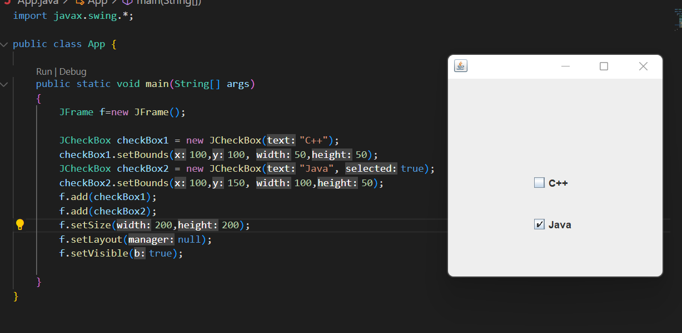

JComboBox
It inherits the JComponent class and is used to show pop up menu of choices.
import javax.swing.*;

public class App {

public static void main(String[] args)
{
JFrame f=new JFrame();
String courses[] = { "core java","advance java", "java servlet"};
JComboBox c = new JComboBox<>(courses);
c.setBounds(40,40,90,20);
f.add(c);
f.setSize(400,400);
f.setLayout(null);
f.setVisible(true);

}
}
Output:
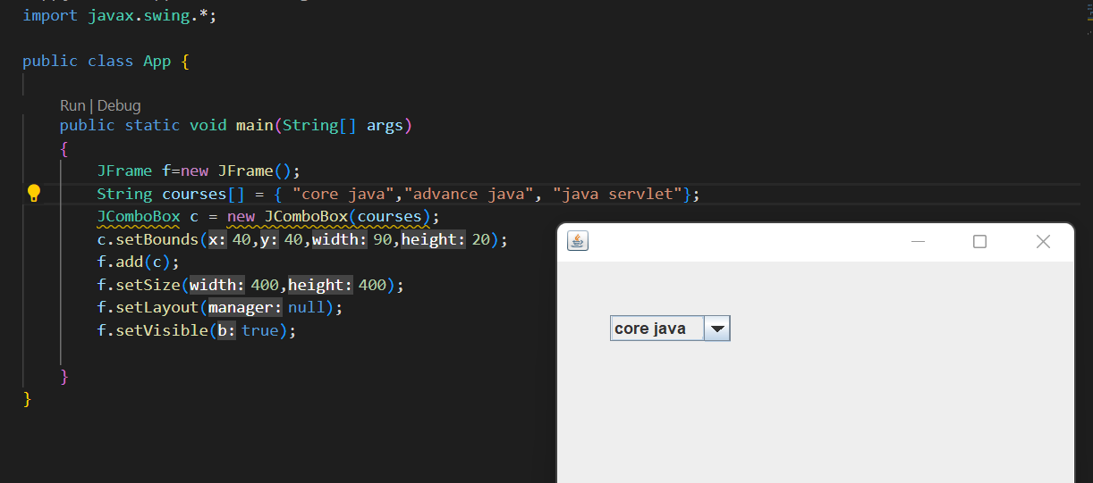
JTextArea
The object of a JTextArea class is a multi line region that displays text. It allows the editing of multiple line text. It inherits JTextComponent class
Commonly used Constructors:

Constructor | Description
JTextArea() | Creates a text area that displays no text initially.
JTextArea(String s) | Creates a text area that displays specified text initially.
JTextArea(int row, int column) | Creates a text area with the specified number of rows and columns that displays no text initially.
JTextArea(String s, int row, int column) | Creates a text area with the specified number of rows and columns that displays specified text.

Code:
import javax.swing.*;

public class App {

public static void main(String[] args)
{
JFrame f=new JFrame();
JTextArea area=new JTextArea("Welcome to javatpoint");
area.setBounds(10,30, 200,200);
f.add(area);
f.setSize(300,300);
f.setLayout(null);
f.setVisible(true);

}
}

Output
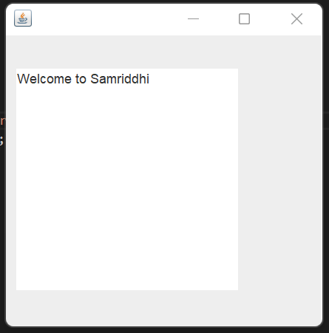

JScrollPane
A JscrollPane is used to make scrollable view of a component. When screen size is limited, we use a scroll pane to display a large component or a component whose size can change dynamically.
Commonly Used Method
Constructor | Purpose
JScrollPane() | It creates a scroll pane. The Component parameter, when present, sets the scroll pane's client. The two int parameters, when present, set the vertical and horizontal scroll bar policies (respectively).
JScrollPane(Component)
JScrollPane(int, int)
JScrollPane(Component, int, int)

Code:
import javax.swing.*;
import java.awt.FlowLayout;

public class App {
App()
{
JFrame f=new JFrame();
// Display the window.
f.setSize(500, 500);
f.setVisible(true);
f.setDefaultCloseOperation(JFrame.EXIT_ON_CLOSE);

// set flow layout for the frame
f.getContentPane().setLayout(new FlowLayout());

JTextArea textArea = new JTextArea(20, 20);

JScrollPane scrollableTextArea = new JScrollPane(textArea);

scrollableTextArea.setHorizontalScrollBarPolicy(JScrollPane.HORIZONTAL_SCROLLBAR_ALWAYS);
scrollableTextArea.setVerticalScrollBarPolicy(JScrollPane.VERTICAL_SCROLLBAR_ALWAYS);

f.getContentPane().add(scrollableTextArea);
}

public static void main(String[] args)
{

javax.swing.SwingUtilities.invokeLater(new Runnable() {

public void run() {
new App();
}
});
}

Output:
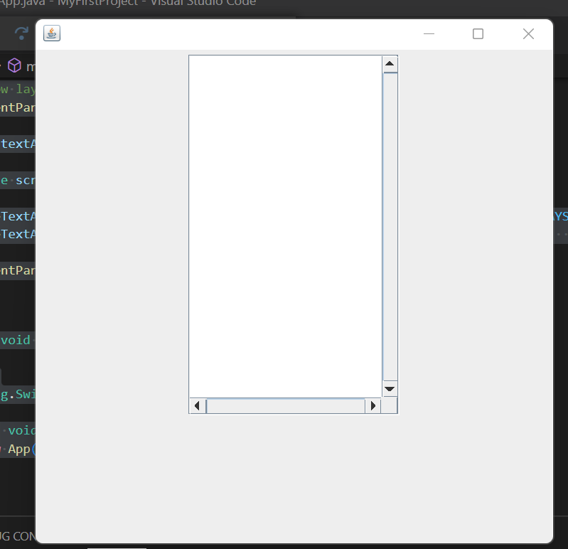
Border Swing Control in Java
The border is an interface using which we can apply a border to every component. To create the borders we have to use the methods available in BorderFactory class. We can apply the created border to any component by using the SetBorder() method.
Syntax: Component.setBorder(Border);
Methods of Border
- Border createLineBorder(Color, int): It is used to create a line border. Here, the Color object specifies the color of the line and int specifies the width in pixels of the line.
- Border createEtchedBorder(int, Color, Color): It is used to create an etched border. Here, Color arguments specify the highlight and shadow colors to be used. Here, int arguments allow the border methods to be specified as either EtchedBorder.RAISED or EtchedBorder.LOWERED. The methods without the int arguments create a lowered etched border.
- Border createBevelBorder(int, Color, Color): It is used to create a raised or lowered beveled border, specifying the colors to use. Here, the integer argument can be either BevelBorder.RAISED or BevelBorder.LOWERED. Here, Color specifies the highlight and shadow colors.
- MatteBorder createMatteBorder(int, int, int, int, Icon): It is used to create a matte border. Here, the integer arguments specify the number of pixels that the border occupies at the top, left, bottom, and right (in that order) of whatever component uses it. Here, the color argument specifies the color which with the border should fill its area. Here, the icon argument specifies the icon which with the border should tile its area.
- TitledBorder createTitledBorder(Border, String, int, int, Font, Color): Create a titled border. Here, the string argument specifies the title to be displayed. Here, the optional font and color arguments specify the font and color to be used for the title’s text. Here, the border argument specifies the border that should be displayed along with the title. Here, the integer arguments specify the number of pixels that the border occupies at the top, left, bottom, and right (in that order) of whatever component uses it.
- CompoundBorder createCompoundBorder(Border, Border): Combine two borders into one. Here, the first argument specifies the outer border; the second, the inner border.

Code:
import javax.swing.*;

public class App {

public static void main(String[] args)
{
JFrame f=new JFrame();
JPanel j=new JPanel();
JTextArea area=new JTextArea("Welcome to Samriddhi");
area.setBorder(BorderFactory.createTitledBorder("Group Box"));
area.setBounds(10,30, 200,200);
f.add(j);
f.add(area);
f.setSize(300,300);
f.setLayout(null);
f.setVisible(true);

}
}

Output:
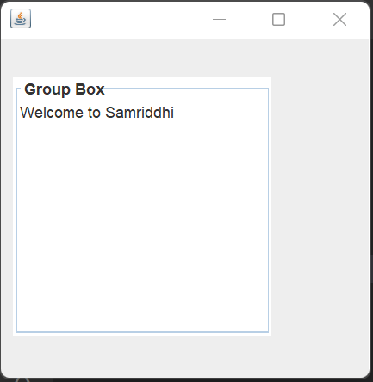

Menu, Menu Item:Code:
import javax.swing.*;

public class App {

public static void main(String[] args)
{
JMenu menu, submenu;
JMenuItem i1, i2, i3, i4, i5;
JFrame f= new JFrame("Menu and MenuItem Example");
JMenuBar mb=new JMenuBar();
menu=new JMenu("Menu");
submenu=new JMenu("Sub Menu");
i1=new JMenuItem("Item 1");
i2=new JMenuItem("Item 2");
i3=new JMenuItem("Item 3");
i4=new JMenuItem("Item 4");
i5=new JMenuItem("Item 5");
menu.add(i1);
menu.add(i2);
menu.add(i3);
submenu.add(i4);
submenu.add(i5);
menu.add(submenu);
mb.add(menu);
f.setJMenuBar(mb);
f.setSize(400,400);
f.setLayout(null);
f.setVisible(true);

}
}

Output:
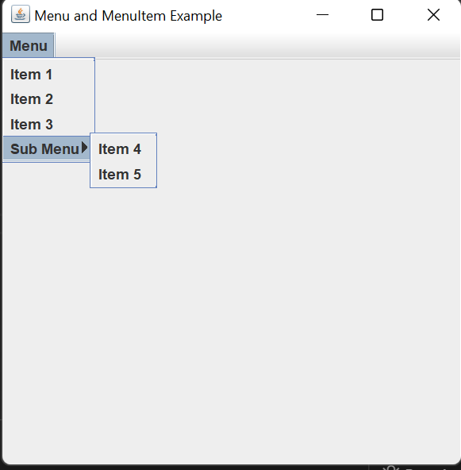
Jpopup Menu
Code:
import javax.swing.*;
import java.awt.event.*;

public class App {

public static void main(String[] args)
{
JFrame f= new JFrame("PopupMenu Example");
JPopupMenu popupmenu = new JPopupMenu("Edit");
JMenuItem cut = new JMenuItem("Cut");
JMenuItem copy = new JMenuItem("Copy");
JMenuItem paste = new JMenuItem("Paste");
popupmenu.add(cut);
popupmenu.add(copy);
popupmenu.add(paste);

f.addMouseListener(new MouseAdapter() {
public void mouseClicked(MouseEvent e) {
popupmenu.show(f , e.getX(), e.getY());
}
});

f.add(popupmenu);
f.setSize(300,300);
f.setLayout(null);
f.setVisible(true);

}
}

Output:
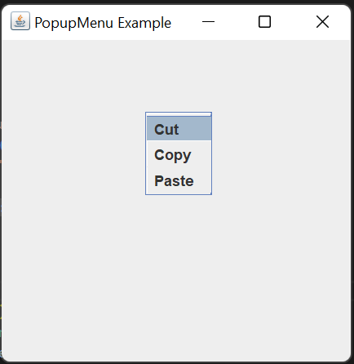
Adding Icon in Menu:

import javax.swing.*;
public class App {

public static void main(String[] args) {

JFrame f=new JFrame("Menu Icon Example");
ImageIcon img=new ImageIcon("new.png");
ImageIcon img2=new ImageIcon("Login.png");
ImageIcon img3=new ImageIcon("Logout.png");
ImageIcon img4=new ImageIcon("Exit.png");
JMenu menu;
JMenuItem i1, i2, i3, i4;

JMenuBar mb=new JMenuBar();
menu=new JMenu("Menu");

i1=new JMenuItem("New",img);
i2=new JMenuItem("Login",img2);
i3=new JMenuItem("Logout",img3);
i4=new JMenuItem("Exit",img4);

menu.add(i1);
menu.add(i2);
menu.add(i3);
menu.add(i4);

mb.add(menu);
f.setJMenuBar(mb);
f.setSize(400,400);
f.setLayout(null);
f.setVisible(true);

}
}

Output:
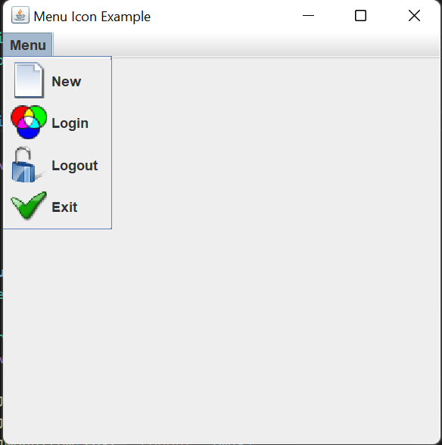

Disable Menu Item
i1.setEnabled(false);
Code:
import javax.swing.*;
public class App {

public static void main(String[] args) {

JFrame f=new JFrame("Menu Icon Example");
ImageIcon img=new ImageIcon("new.png");
ImageIcon img2=new ImageIcon("Login.png");
ImageIcon img3=new ImageIcon("Logout.png");
ImageIcon img4=new ImageIcon("Exit.png");
JMenu menu;
JMenuItem i1, i2, i3, i4;

JMenuBar mb=new JMenuBar();
menu=new JMenu("Menu");

i1=new JMenuItem("New",img);
i2=new JMenuItem("Login",img2);
i3=new JMenuItem("Logout",img3);
i4=new JMenuItem("Exit",img4);

menu.add(i1);
menu.add(i2);
menu.add(i3);
menu.add(i4);
i1.setEnabled(false);

mb.add(menu);
f.setJMenuBar(mb);
f.setSize(400,400);
f.setLayout(null);
f.setVisible(true);

}
}

Adding Tooltip:
i1.setToolTipText("It Creates New");
Code:
import javax.swing.*;
public class App {

public static void main(String[] args) {

JFrame f=new JFrame("Menu Icon Example");
ImageIcon img=new ImageIcon("new.png");
ImageIcon img2=new ImageIcon("Login.png");
ImageIcon img3=new ImageIcon("Logout.png");
ImageIcon img4=new ImageIcon("Exit.png");
JMenu menu;
JMenuItem i1, i2, i3, i4;

JMenuBar mb=new JMenuBar();
menu=new JMenu("Menu");

i1=new JMenuItem("New",img);
i2=new JMenuItem("Login",img2);
i3=new JMenuItem("Logout",img3);
i4=new JMenuItem("Exit",img4);

menu.add(i1);
menu.add(i2);
menu.add(i3);
menu.add(i4);
i1.setToolTipText("It Creates New");

mb.add(menu);
f.setJMenuBar(mb);
f.setSize(400,400);
f.setLayout(null);
f.setVisible(true);

}
}

Output:
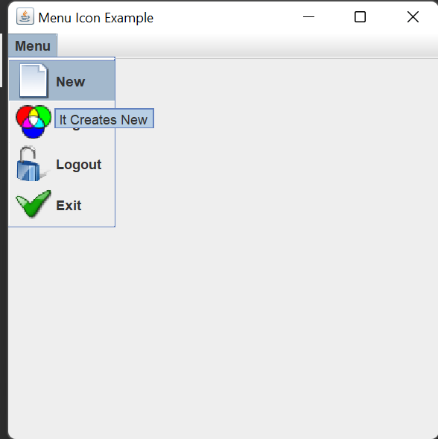

Toolbar :
import javax.swing.*;
import java.awt.*;
public class App {

public static void main(String[] args) {

JFrame f=new JFrame("Menu Icon Example");
ImageIcon img1=new ImageIcon("new.png");
ImageIcon img2=new ImageIcon("Login.png");
ImageIcon img3=new ImageIcon("Logout.png");

JToolBar toolbar = new JToolBar();
// create a panel
JPanel p = new JPanel();

JButton newBtn = new JButton(img1);
JButton openBtn = new JButton(img2);
JButton saveBtn = new JButton(img3);

toolbar.add(newBtn);
toolbar.add(openBtn);
toolbar.add(saveBtn);

// add panel to toolbar

toolbar.add(p);
// add toolbar to frame
f.add(toolbar, BorderLayout.NORTH);

// set the size of the frame
f.setSize(500, 500);
f.setVisible(true);

}
}

Output:
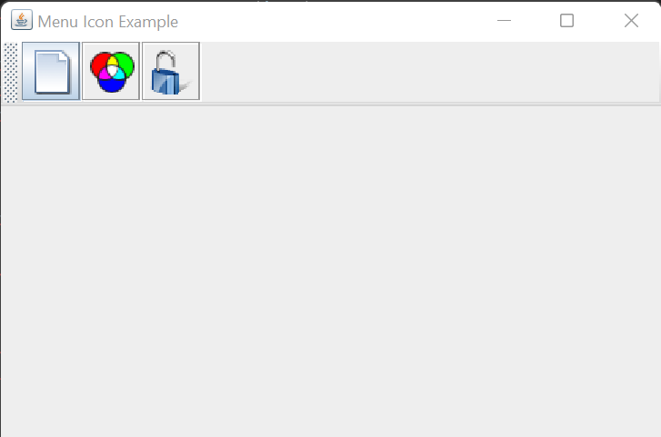
Keyboard Mnemonics and Accelerators:
Keyboard Mnemonics:
A menu mnemonic is a single-letter abbreviation for a menu command. When the menu has already been pulled down, the user can type this single key to invoke that menu item. The mnemonic for a menu item is typically indicated by underlining the letter of the shortcut in the menu item name, which means that you must select a shortcut letter that appears in the menu item label. Mnemonics must be unique within a menu, You specify a mnemonic for a menu or a menu item with the setMnemonic() method.
Example:
import javax.swing.*;

public class App {
public static void main(String[] args) {

JMenu menu, submenu;
JMenuItem i1, i2, i3, i4, i5;

JFrame f= new JFrame("Menu and MenuItem Example");
JMenuBar mb=new JMenuBar();
menu=new JMenu("Menu");
menu.setMnemonic('M');
submenu=new JMenu("Sub Menu");
i1=new JMenuItem("Item 1");
i2=new JMenuItem("Item 2");
i3=new JMenuItem("Item 3");
i4=new JMenuItem("Item 4");
i5=new JMenuItem("Item 5");
menu.add(i1);
menu.add(i2);
menu.add(i3);
submenu.add(i4);
submenu.add(i5);
menu.add(submenu);
mb.add(menu);
f.setJMenuBar(mb);
f.setSize(400,400);
f.setLayout(null);
f.setVisible(true);

}
}
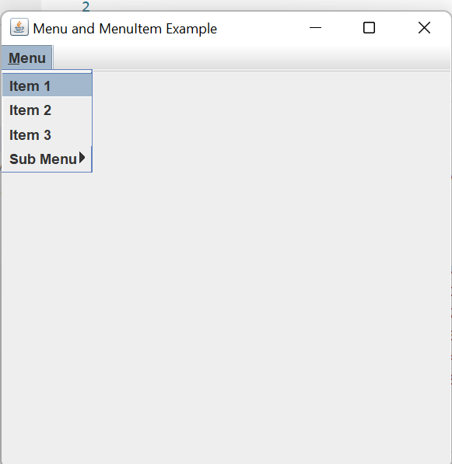

Menu Accelerators:
A menu accelerator is a unique keyboard command that can be used to invoke a menu item even when the menu is not displayed. An accelerator is represented by a javax.swing.KeyStroke object and usually includes a keyboard modifier such as Ctrl or Alt. Unlike mnemonics, accelerators can be applied only to menu items, not to menus in a menu bar. You can create an accelerator for a menu item by calling setAccelerator(). To obtain an appropriate KeyStroke object, call the static KeyStroke.getKeyStroke() method with the keycode and modifier mask for the keyboard command you want to use:
Example:
import javax.swing.*;
import java.awt.event.*;

public class App {
public static void main(String[] args) {

JMenu menu;
JMenuItem i1, i2, i3;

JFrame f= new JFrame("Menu and MenuItem Example");
JMenuBar mb=new JMenuBar();
menu=new JMenu("File");
menu.setMnemonic('F');

i1=new JMenuItem("Open");
i2=new JMenuItem("Save");
i3=new JMenuItem("Close");
i2.setAccelerator( KeyStroke.getKeyStroke(KeyEvent.VK_S, ActionEvent.CTRL_MASK));

menu.add(i1);
menu.add(i2);
menu.add(i3);

mb.add(menu);
f.setJMenuBar(mb);
f.setSize(400,400);
f.setLayout(null);
f.setVisible(true);

}

}

